**Cloud formation 27th Sep 2024 Practical**

1. **Create s3 bucket in cloud formation**

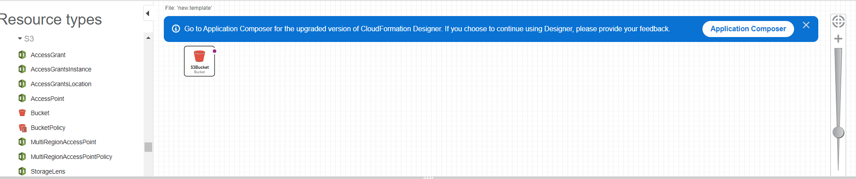

1. **Yaml code**

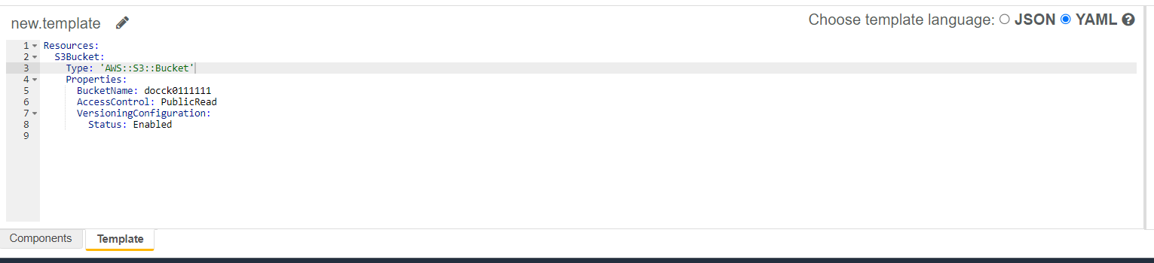

1. **Create stack (Amazon s3 URL)**

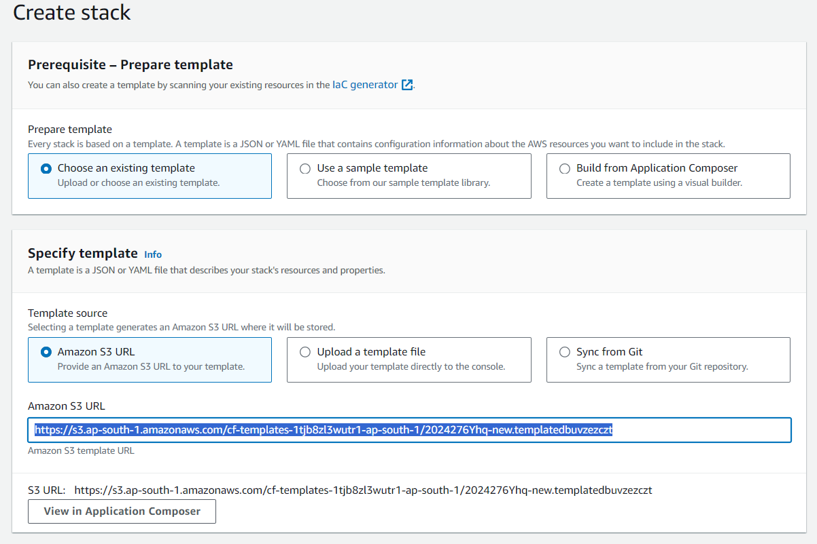

1. **Specify Stack details (s3bucket-demo)**

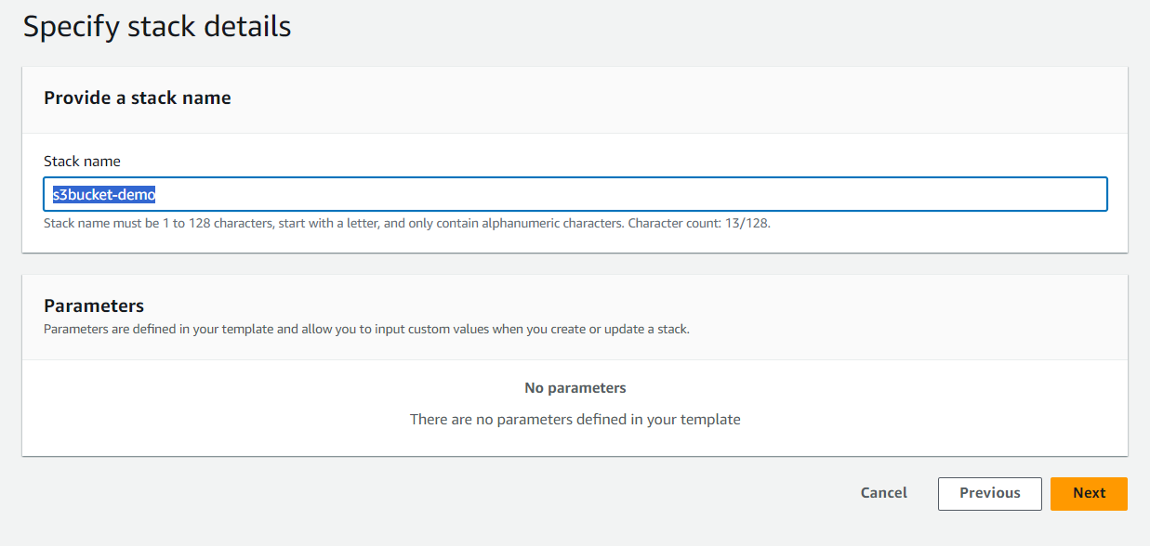

1. **Review and create**

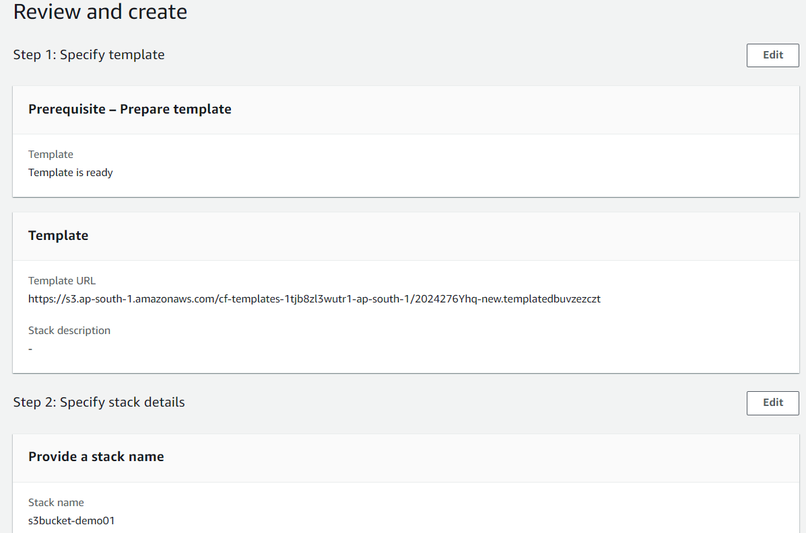

1. **Create in progress (s3 bucket demo01)**

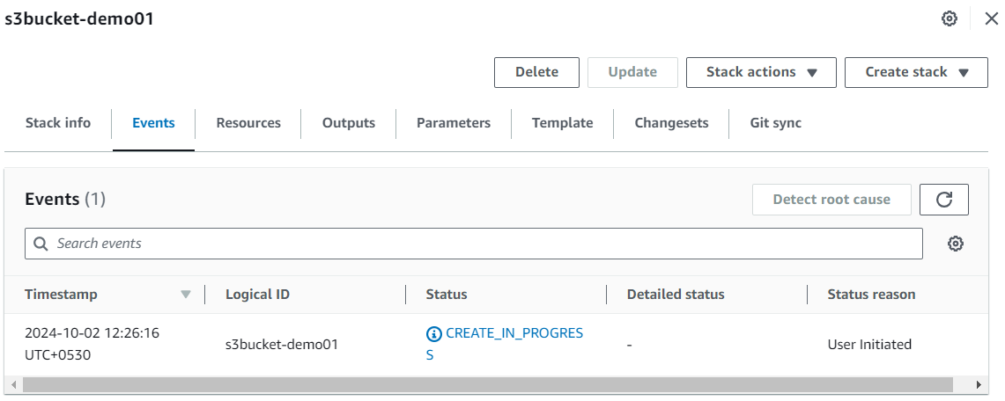

1. **Create complete**

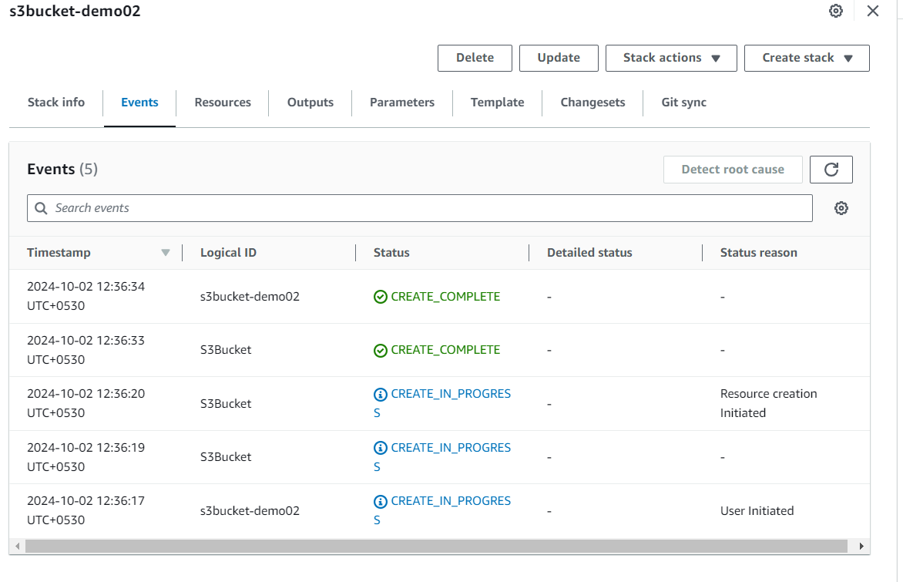

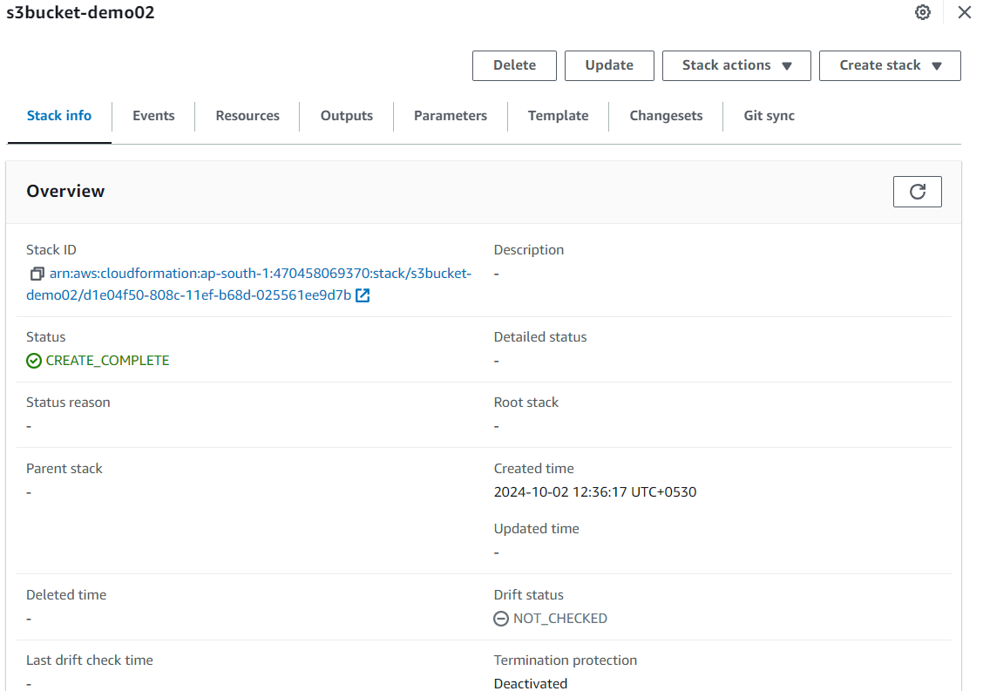

**Create s3 bucket**

